**Oracle 12C Step by step Installation:**

**Step 1: Prerequisites**

**Packages:**  
First, we need to install the required packages. These packages we can easily get from OS officially repository.

# yum install -y binutils.x86_64 compat-libcap1.x86_64 gcc.x86_64 gcc-c++.x86_64 glibc.i686 glibc.x86_64 glibc-devel.i686 glibc-devel.x86_64 ksh compat-libstdc++-33 libaio.i686 libaio.x86_64 libaio-devel.i686 libaio-devel.x86_64 libgcc.i686 libgcc.x86_64 libstdc++.i686 libstdc++.x86_64 libstdc++-devel.i686 libstdc++-devel.x86_64 libXi.i686 libXi.x86_64 libXtst.i686 libXtst.x86_64 make.x86_64 sysstat.x86_64 zip unzip

**Host File:**  
The host file must contain a fully qualified name for the server.

127.0.0.1 oracle.techoism.net oracle  
192.168.1.110 oracle.techoism.net oracle

**Selinux:**  
Set secure Linux to permissive using selinux configuration file.

# vim /etc/sysconfig/selinx

Change the parameters.

SELINUX=permissive

Reboot the server or execute the mentioned command.

# setenforce Permissive

**IPTables:**  
If on server Linux firewall is enabled, so you need to stop it and need to configure it.

**For CentOS/RHEL 7**  
# systemctl stop firewalld  
# systemctl disable firewalld  
**For CentOS/RHEL 6**  
# service iptables stop  
# chkconfig iptables off

**Step 2: Create User and Group**

Oracle database will run with a normal Linux user. So we need to create the user and group for Oracle.

# groupadd oinstall  
# groupadd dba  
# useradd -g oinstall -G dba oracle

Set the oracle user password.

# passwd oracle

**Step 3: Kernel Parameters**

Now we need to configure our system before starting the installation of Oracle Database. Add mention kernel parameters in sysctl.conf file.

# vim /etc/sysctl.conf

Add the mention lines.

fs.aio-max-nr = 1048576  
fs.file-max = 6815744  
kernel.shmall = 2097152  
kernel.shmmax = 8329226240  
kernel.shmmni = 4096  
kernel.sem = 250 32000 100 128  
net.ipv4.ip_local_port_range = 9000 65500  
net.core.rmem_default = 262144  
net.core.rmem_max = 4194304  
net.core.wmem_default = 262144  
net.core.wmem_max = 1048586

Reload the configuration file to reflect the changes.

# sysctl -p  
# sysctl -a

Next, we need to configure some limits for the oracle user.

# vim /etc/security/limits.conforacle soft nproc 2047  
oracle hard nproc 16384  
oracle soft nofile 1024  
oracle hard nofile 65536  
oracle soft stack 10240  
oracle hard stack 32768

**Step 4: Configure X11 Forwarding**

X11 forwarding refers to executing such a program remotely through an SSH (Secure Shell) connection. With X11 you can easily install the Oracle Database. You can use mention link to configure X11 on the server.

[X11 Configuration](http://www.techoism.com/configure-x11-forwarding-centosrhel-67/)

**Step 5: Create the Directories**

Before installing Oracle Database, create directories that will be used during the Oracle installation, and provide the required permissions.

# mkdir /u01  
# chown -R oracle:oinstall /u01  
# chmod -R 775 /u01  
# chmod g+s /u01

**Step 6: Extract the File**

Once you will download the Oracle database setup from Oracle official website. Extract the Oracle files on a Linux server.

# cd /software  
# unzip linuxx64_12201_Oracle_database.zip

**Step 7: Install Oracle Database**

Start the Oracle Database Installer issuing the following command in the database directory.

# cd /software/database  
# ./runInstaller

Image for post

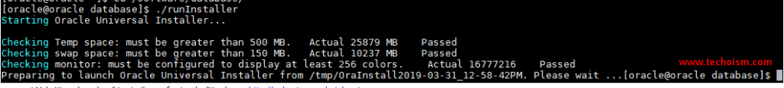

Provide your email address to be informed of security issues and click “Enter”

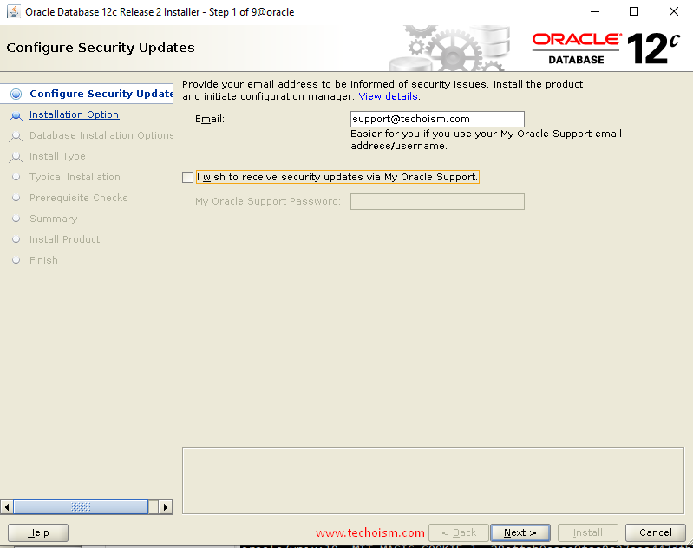

If you are using any proxy server then provide the details of the proxy server and click “Continue”

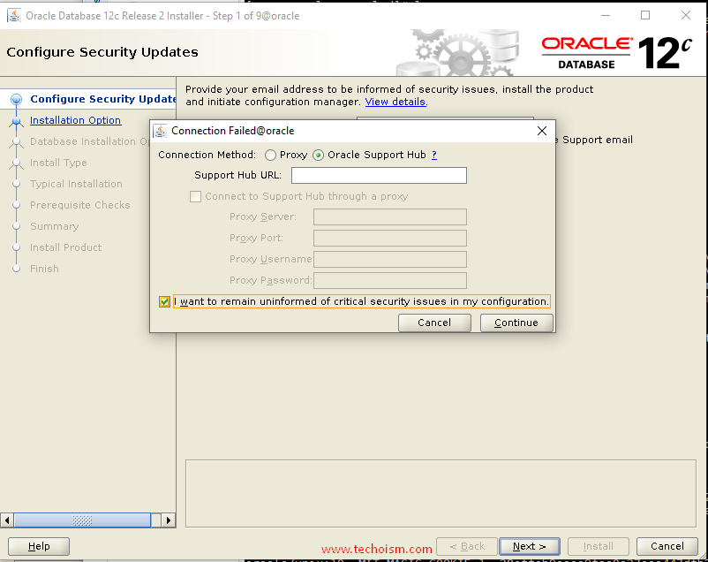

Choose create and configure a database option and click “Next”

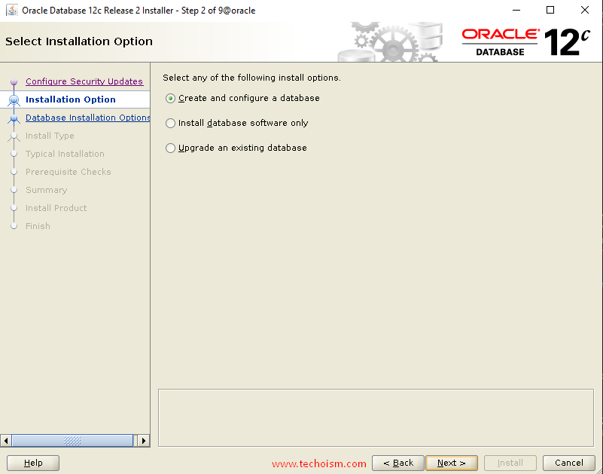

Under the ‘System Class’ section, choose system class and click “Next” again.

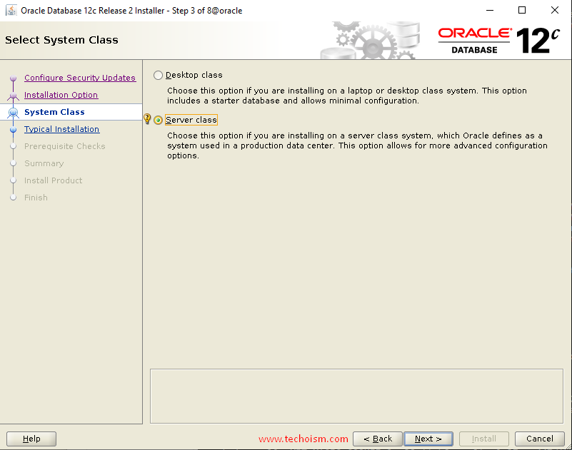

In this section, Select the type of installation you want to select and click “Next”

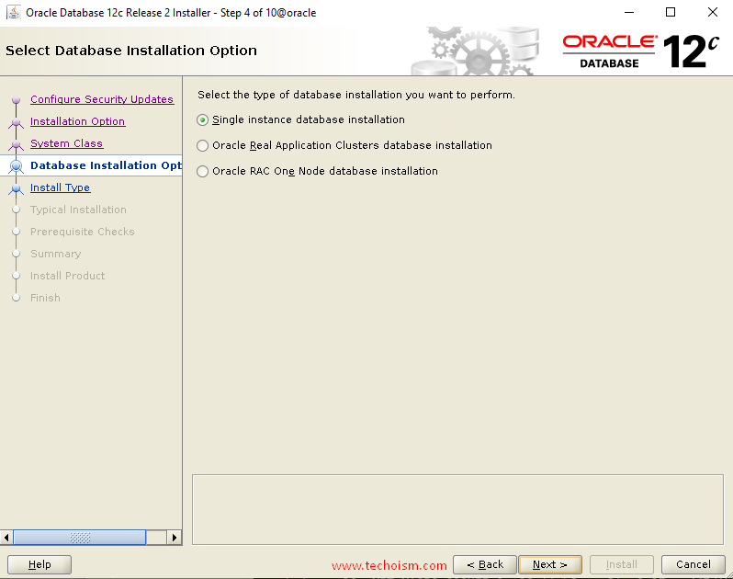

Select the installation type and click “Next”

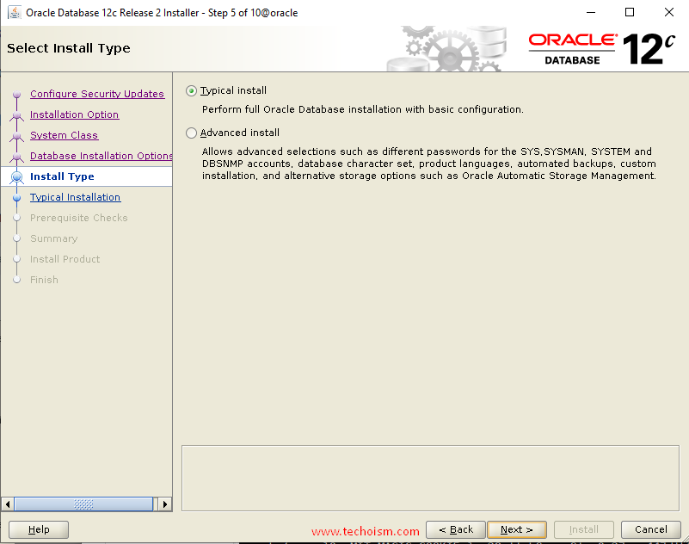

Now specify full database installation with basic configuration and click “Next”

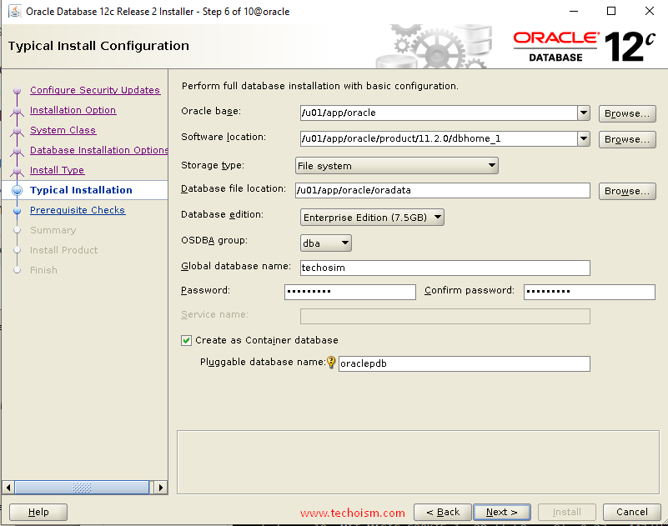

You are starting your first installation on the host. Specify a directory for Installation metadata files and click “Next”

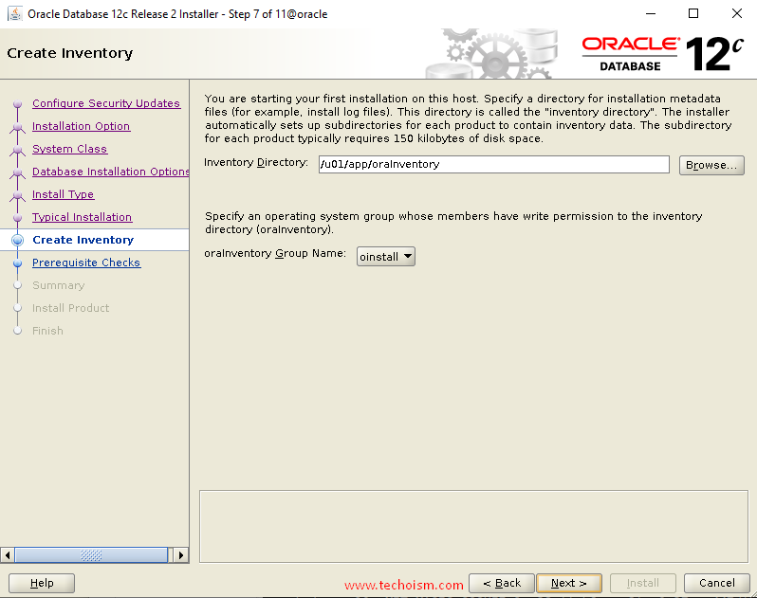

Verify that the installation pre-checks are completed without errors. then it will show the summary of the information such as global settings, database information, etc. Review the information and click “install”.

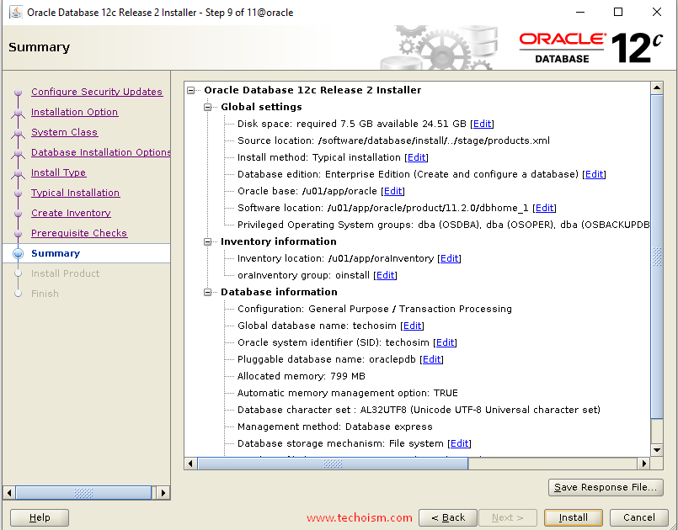

Now the installation of Oracle Database has been started. It will take a few minutes to complete.

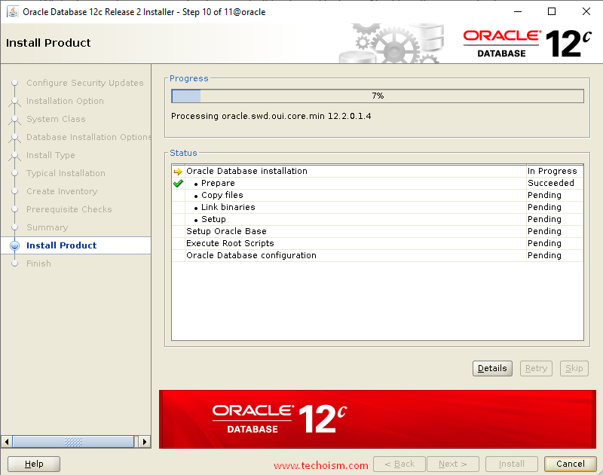

During the installation, you need to run a couple of scripts to set the required permissions.

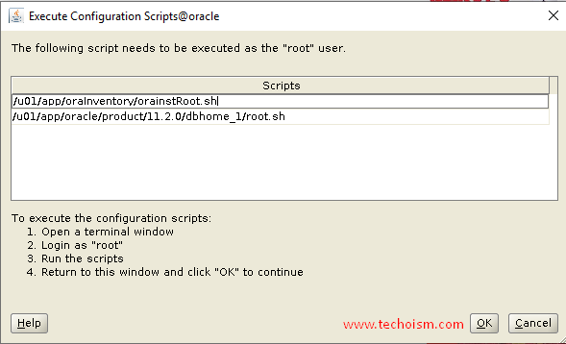

# /u01/app/oraInventory/orainstRoot.shChanging permissions of /u01/app/oraInventory.  
Adding read,write permissions for group.  
Removing read,write,execute permissions for world.Changing groupname of /u01/app/oraInventory to oinstall.  
The execution of the script is complete.# /u01/app/oracle/product/11.2.0/dbhome_1/root.shPerforming root user operation.  
 The following environment variables are set as:  
 ORACLE_OWNER= oracle  
 ORACLE_HOME= /u01/app/oracle/product/11.2.0/dbhome_1  
 Enter the full pathname of the local bin directory: [/usr/local/bin]:  
 Copying dbhome to /usr/local/bin ...  
 Copying oraenv to /usr/local/bin ...  
 Copying coraenv to /usr/local/bin ...  
 Creating /etc/oratab file...  
 Entries will be added to the /etc/oratab file as needed by  
 Database Configuration Assistant when a database is created  
 Finished running generic part of root script.  
 Now product-specific root actions will be performed.  
 Do you want to setup Oracle Trace File Analyzer (TFA) now ? yes|[no] :  
 Oracle Trace File Analyzer (TFA - User Mode) is available at :  
 /u01/app/oracle/product/11.2.0/dbhome_1/suptools/tfa/release/tfa_home/bin/tfactl  
 OR  
 Oracle Trace File Analyzer (TFA - Daemon Mode) can be installed by running this script :  
 /u01/app/oracle/product/11.2.0/dbhome_1/suptools/tfa/release/tfa_home/install/roottfa.sh

Image for post



Oracle database configuration has been completed and clicks “Next”.

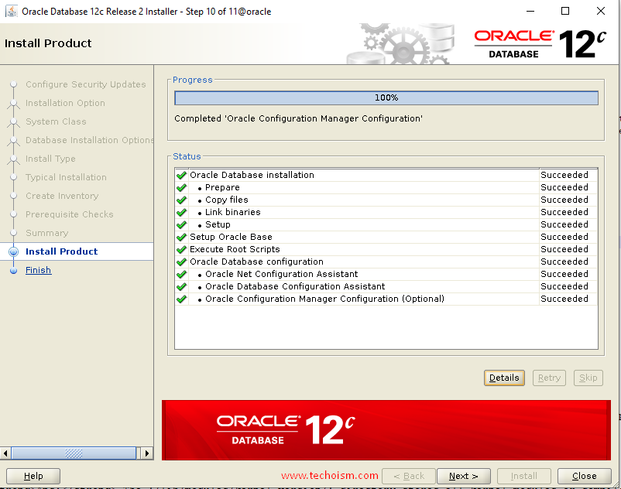

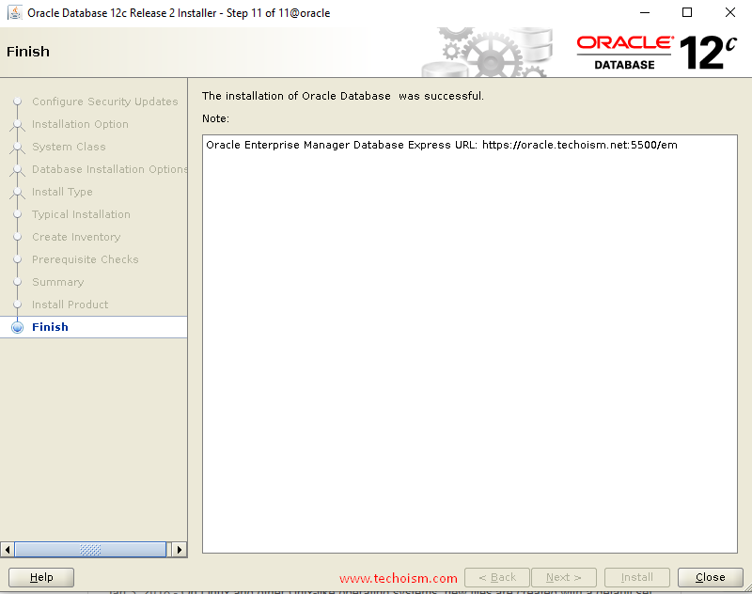

**Step 8: Access Oracle Enterprise Manager**

When it is finished, you will be presented with the message indicating the URL of the Oracle Enterprise Manager:

<https://oracle.techoism.net:5500/em>

**Step 10: Set Oracle Home Directory**

Add the following lines in the user home directory at .bash_profile file.

# su - oracle  
# vim .bashrcTMPDIR=$TMP; export TMPDIR  
ORACLE_BASE=/u01/app/oracle; export ORACLE_BASE  
ORACLE_HOME=$ORACLE_BASE/product/12.1.0/dbhome_1; export ORACLE_HOME  
ORACLE_SID=techoism; export ORACLE_SID  
PATH=$ORACLE_HOME/bin:$PATH; export PATH  
LD_LIBRARY_PATH=$ORACLE_HOME/lib:/lib:/usr/lib:/usr/lib64; export LD_LIBRARY_PATH  
CLASSPATH=$ORACLE_HOME/jlib:$ORACLE_HOME/rdbms/jlib; export CLASSPATH

Execute the mentioned command.

# source .bash_profile

**Step 11: Listener File Configuration**

Finally, replace the host in the listener.ora file.

# vim $ORACLE_HOME/network/admin/listener.ora

Find the below parameter.

(ADDRESS = (PROTOCOL = TCP)(HOST = oracle.techoism.net)(PORT = 1521)

Change the parameter with 0.0.0.0

(ADDRESS = (PROTOCOL = TCP)(HOST = 0.0.0.0)(PORT = 1521)

**Step 12: Enabling Oracle to Start on System Boot**

To enable the database service to start automatically on boot, create the service file for the Oracle database and add the mention lines.

# vim /etc/systemd/system/oracle-rdbms.service#/etc/systemd/system/oracle-rdbms.service  
#Invoking Oracle scripts to start/shutdown Instances defined in /etc/oratab #and starts Listener[Unit]  
Description=Oracle Database(s) and Listener  
Requires=network.target[Service]  
Type=forking  
Restart=no  
ExecStart=/u01/app/oracle/product/12.2.0/dbhome_1/bin/dbstart /u01/app/oracle/product/12.2.0/dbhome_1  
ExecStop=/u01/app/oracle/product/12.2.0/dbhome_1/bin/dbshut /u01/app/oracle/product/12.2.0/dbhome_1  
User=oracle[Install]  
WantedBy=multi-user.target

Finally, indicate to the database to be brought up during boot.

# vim /etc/oratab

Find the mentioned line.

techoism:/u01/app/oracle/product/12.2.0/dbhome_1:N

Replace ’N’ with ‘Y’.

techoism:/u01/app/oracle/product/12.2.0/dbhome_1:Y